CTU Training Solutions
Diploma in IT – Network Design and Administration
NET731 – Week 1
Project Planning & Azure Setup
NET731 | NQF Level 7 | Week 1 of 10 | 10 Marks
6 – 12 March 2026

Overview
This week you will begin your 10-week Azure capstone project. By the end of this session you will have:
- Activated your Azure for Students account
- Created your Azure Resource Group with proper tags
- Identified the business requirements for your scenario
- Documented the Azure services you will use throughout the project
- Set up your GitHub repository and uploaded your first evidence

Marks | 10 marks
Submission | Upload evidence to GitHub under: NET731 > Week1
Deadline | 9 March 2026

Scenario
You have been appointed as an Azure Administrator for CTU Training Solutions. The company is expanding and needs a cloud-based infrastructure to support their operations. Your manager has asked you to design, deploy, and manage the Azure environment over the next 10 weeks.

This week your job is to plan the project, set up your Azure environment, and document what you are going to build.

Task 1 – Set Up Azure for Students

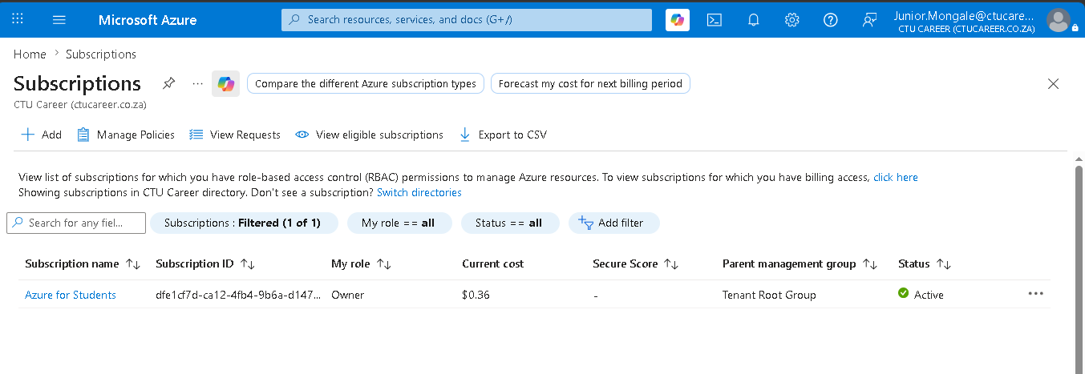

Task 2 – Define Business Requirements
Based on the CTU Training Solutions scenario, you need to document what the business needs from its Azure environment. In a Word document, answer the following:

Business Requirements to document:
- What type of organisation is CTU Training Solutions? (Size, industry, purpose)
- What are the main IT needs of the organisation? (Consider: staff, students, data, applications)
- Why would a cloud solution (Azure) be more beneficial than on-premises infrastructure for CTU?
- What security and compliance requirements should be considered?
- What is the expected number of users who will access the cloud environment?

CTU Training Solutions – Azure Environment Planning
CTU Training Solutions is a medium to large sized organization with maybe 30 employees and about 400 students in a campus. It’s in the industry of Education and training, The CTU Training Solution provides academic and technical training to students through campuses and online learning platforms (MS Teams). The IT support needed is email and communication services, servers and virtual machines, backup and recovery solutions, lastly is remote access for online learning and staff. Easy scaling as the organization grows, also the back and disaster recovery features. As for security and compliances you should configure MFA, RBAC, and create secure networks and firewalls.

Task 3 – Identify Required Azure Services
Based on the 10-week project plan, list and describe each Azure service you will use. Use the table below as a guide for your documentation:

Azure Service | Purpose / Why you need it | Week it is used
Resource Group | Used to group and manage all related Azure resources for a project together for easier deployment. | 1
Virtual Network (VNet) | Provides a private environment for resources to communicate securely with each other (the internet and your network) | 2
Virtual Machine (VM – B1s) | On-demand, scalable computing resources. B1s size is low cost and best for small workloads like web servers. | 3
Microsoft Entra ID | Cloud based identity and access management service that controls who can sign in and what resources they can access. | 4
Network Security Group (NSG) | Allows you to filter network traffic from Azure resources based on IP address, port and protocol. | 5
Azure Storage Account | An account that gives you a unique namespace to store and manage your data object such as blobs. | 6
Microsoft Defender for Cloud | A management system that protects your cloud resources by identifying vulnerabilities. | 7
Azure Monitor | A tool collecting, analyzing and acting on telemetry data from your cloud and on-premises environment to maximize performance. | 8
Azure Cost Management | A tool used to help you monitor, allocate and optimize your Azure spending so you don’t exceed your budget/limit. | 9

Task 4 – Create Your Azure Resource Group
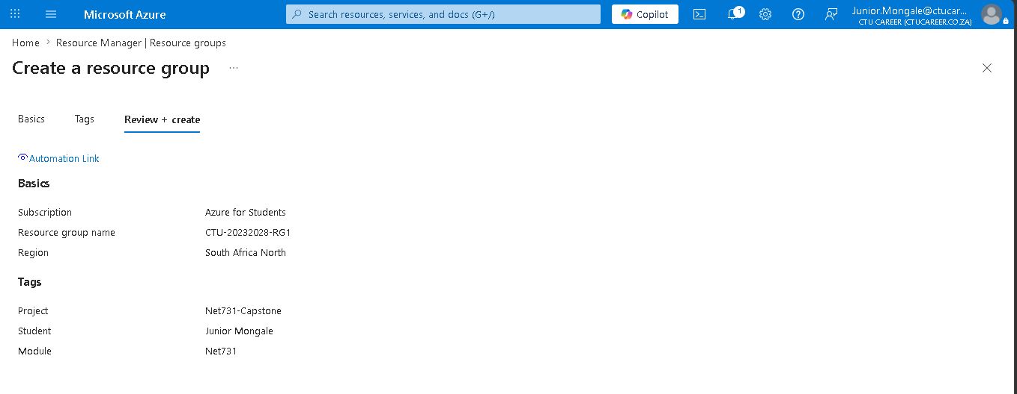

Marking Criteria – Week 1 (10 Marks)
Criteria | Marks
Business requirements clearly defined and documented | 3
Azure services identified with purpose and week mapping | 3
Resource Group created with correct name, region, and tags | 2
Evidence uploaded to GitHub in correct folder | 2

